# Astronomy Webpage ***(PROBITY MAHLABANE)***

This a simple, educational astronomy-themed website built using HTML and CSS. This project was originally created as part of as university assignment to demonstate core frontend develpoment skills and visual content structuring.

## Features

- Multipage layout (Home, Planents, black wholes, etc.)

- Clean and responsive design

- Embedded images and videos of astronomical content

- Custom navigation menu

- Organised folder structure for images and videos

## Technologies Used

- HTML5

- CSS3

## Folder structure

/root

-- index.html

-- page1.html to page35.html

-- styles.css to styles 3.html

-- nav.css

/images

*.jpg, *.png

/videos

*.mp4

## Screenshots

[Homepage screen shots]

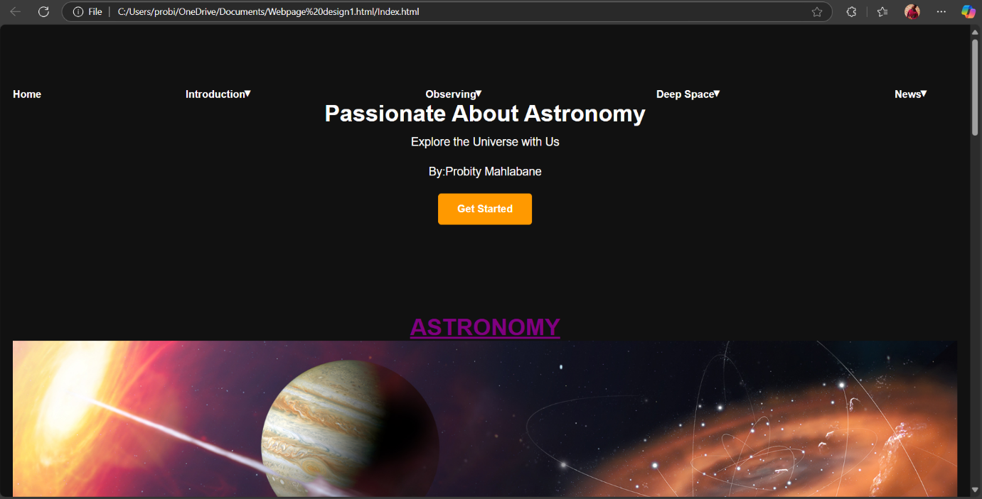

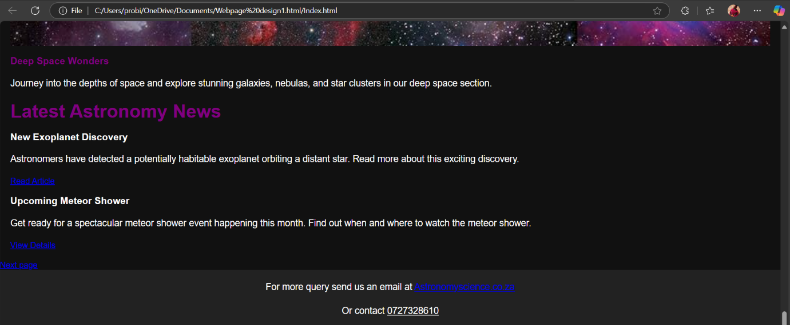

**This project helped me:**

* Understand the structure of multi-page HTML sites
* Improve CSS layout and design skills
* Practice orginizing and referencing local assets like videos and images
* Get hands on experience with clean code formatting and comments